Department of Computer Science and Engineering (Data Science)
CSDS-A | Batch A6 (CSE - Data Science, Section A)
ClauseGuard: Legal Contract Complexity and Predatory Clause Detector
(ClauseGuard)
S.No. | Student name | Roll / hall ticket no.
1 | CH.PRANATHI | 23K91A6744
2 | G.PRANAVI | 23K91A6762
3 | G.CHARAN JOSEPH | 23K91A6753
4 | G.BHAGWATH | 23K91A6760
Under the guidance of: [GUIDE NAME], [DESIGNATION]
SCOPE AND LIMITATIONS
This document states what ClauseGuard covers and what it deliberately does not, the assumptions behind the design, and the honest limitations of the system and of the evidence for it.

1 Scope of the Project

1.1 In scope
- Contracts in English as PDF (with real page numbers) or DOCX files, read for text; the file is removed from the server after analysis.
- Segmentation into clauses at numbered headings (1., 2.1, Section 3, Article 4), with a paragraph-merging fallback.
- Classification of each clause into one of twenty substantive CUAD categories by Gemini embedding and nearest centroid, with an optional language-model tie-break.
- Eight predatory-clause rules (restraint of trade, penalty versus liquidated damages, unilateral termination, unlimited liability, one-sided arbitration, automatic renewal, intellectual-property overreach, no-refund) and three risky combinations.
- A complexity grade from readability, legalese density, cross-references and sentence length, and a Gemini plain-language summary with key obligations.
- A web application with sign-up and log-in, upload, a contract list, a report, a clause detail page, a clause graph and an evaluation page, and a REST API with JWT authentication.
- Separate evaluation of classification and predatory detection, a probe set of independently written clauses, a run over all 510 CUAD contracts, API timings and an automated test suite.

1.2 Out of scope
- Legal advice. The output is information to help a signatory prepare questions for a lawyer; no lawyer reviewed the explanations.
- Training or fine-tuning a model. Nothing is trained; the twenty centroids are means of cached example embeddings.
- Scanned or image-only documents (no OCR), languages other than English, and documents other than contracts.
- A corpus of Indian contracts, a case-law or statute retrieval index, precedent modelling, and a Neo4j or pgvector deployment.
- Negotiation, redlining and e-signature, multi-user organisations, and any payment feature.
- Production hardening such as HTTPS termination, rate limiting, a hosted database and load testing.

1.3 Assumptions
- The uploaded file contains selectable text and numbered clause headings in the form the segmenter recognises.
- A Gemini API key with enough quota is available; the build was measured on a shared free-tier key.
- The eight rules and three combinations encode the author's reading of the cited statutes and are not a complete statement of Indian law.
- The application runs on one machine with a single SQLite database for one demonstration deployment.

2 System Boundary
The two diagrams below show the boundary of ClauseGuard: what flows across it (context diagram) and who may do what inside it (use-case diagram).
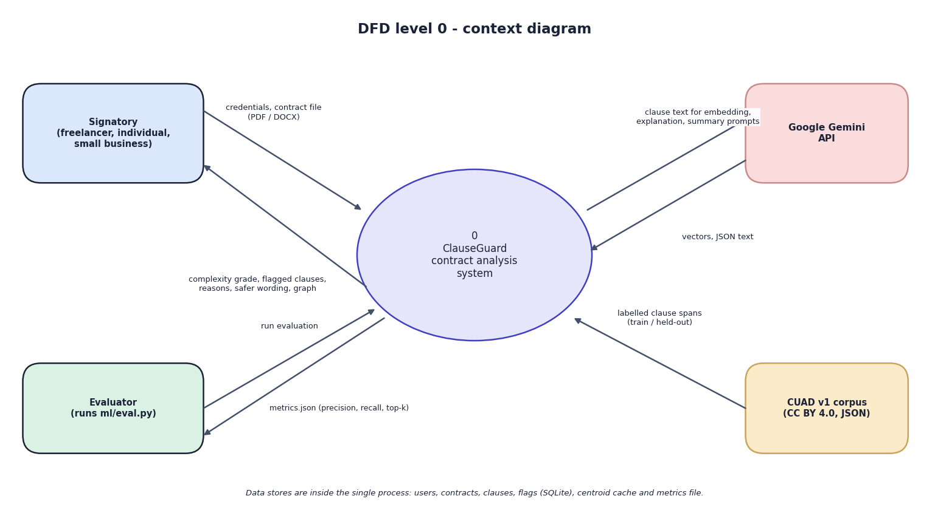
Fig. 1: Data-flow diagram, level 0 (context)
At the highest level ClauseGuard is one process with four external entities. The signatory, who may be a freelancer, an individual or a small business, sends credentials and a contract file and receives the complexity grade, the flagged clauses with reasons and safer wording, and the clause graph. Google Gemini receives clause text and prompts and returns vectors and JSON text. The evaluator, who is whoever runs ml/eval.py, starts an evaluation and receives metrics.json with the precision, recall and top-k scores; the CUAD v1 corpus supplies the labelled clause spans from which the training and held-out sets were drawn. The data stores are inside the single process and are not drawn at this level.
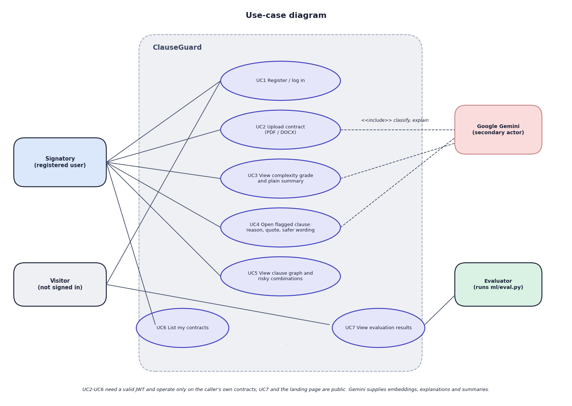
Fig. 2: Use-case diagram
Four actors appear. The signatory (a registered user) registers or logs in (UC1), uploads a contract (UC2), views the grade and plain summary (UC3), opens a flagged clause to read the reason, the quoted provision and the safer wording (UC4), views the clause graph and the risky combinations (UC5), and lists the contracts (UC6). The visitor, who is not signed in, can register or log in and can open the evaluation page (UC7), which is public. The evaluator runs ml/eval.py, which produces the figures that UC7 shows. Google Gemini is a secondary actor attached to the use cases that call it: uploading (classification and explanation), the summary and the clause explanation.
Use cases UC2 to UC6 need a valid token and work only on the caller's own contracts. There is no administrator role, no sharing between users and no way to edit or delete a contract in the interface.

3 Limitations and Assumptions
- The rules are regular expressions. On the independent probe set they miss 13 of 24 predatory clauses (recall 0.458) because they need the keyword, and they flag three of 16 benign look-alikes. The 40-clause test set was written by the author of the rules, so its scores (1.000 precision, 0.941 recall) are an upper bound, and the Evaluation screen's wording "held-out" overstates it.
- Classification is measured on annotation spans. The 240 test items are CUAD answer spans of about 290 characters, whereas the product classifies whole clauses of about 1,158 characters. In 19 whole clauses from two uploaded contracts about half of the labels were plausible (author's reading, indicative only). The split is by text and not by contract (192 of 240 items share a contract with training examples), although the contract-disjoint score is similar (0.800).
- Two thresholds never act. On the 240 spans the top similarity ranges from 0.657 to 0.849, so the tie-break (which needs a value below 0.60) and the Unclassified floor (below 0.35) are never reached, and every clause receives one of the twenty labels even if it belongs to none.
- Input format matters. PDF line breaks defeat rules that use a bounded gap between key phrases (6 of 8 rules found in the PDF form of a contract for which the DOCX form gives 8 of 8); text before the first numbered heading is discarded; 84 of 510 CUAD contracts produce fewer than five clauses; scanned PDFs cannot be read.
- The complexity grade is lexical. It does not measure fairness, and its weights and cut-offs were chosen by the author and are not validated against human ratings.
- Language-model output is unverified. Explanations, safer wording and summaries come from Gemini, were not checked by a lawyer, and were not measured for errors.
- No Indian contract data. CUAD consists of US filings; no corpus of Indian contracts was available, so nothing was evaluated on Indian documents.
- Dependence on a hosted model. The free tier of the default text model allowed 20 requests per day; a call takes about 12 s; the user interface times out after 180 s, so a contract with many flags could fail in the browser although the server would finish.
- Single machine, single database, no load, concurrency or penetration testing, and no user study.

4 Advantages and Constraints
Table 1: Advantages and constraints of the project
Advantages | Constraints
Runs on one ordinary PC with no GPU, no training and no licence fee | Depends on a hosted model: quota (20 text requests per day observed), cost on a paid tier unmeasured, about 12 s per call
Every flag shows the quoted provision, the rule's legal basis and a safer wording | Eight regular-expression rules: recall 0.458 on independently written clauses
Classification and predatory detection are scored separately (top-1 0.792; precision/recall on two sets) | No Indian contract corpus; CUAD is US data; spans, not whole clauses, were scored
Combinations of clauses are reported, which clause-by-clause tools do not do | Only three combinations, matched anywhere in the contract
Non-API processing is fast (56 ms per contract; 2.5-15 ms for read endpoints) | PDF line breaks lose some rules; scanned PDFs cannot be read; no OCR
Authenticated API: bcrypt, JWT, owner check on every contract route | CORS is open, the default signing key applies when .env has none, and there is no rate limiting

5 Limits of the Testing Done
- The automated tests stub Gemini, so they say nothing about the quality of the generated explanations, safer wording and summaries, and nothing about real embedding quality.
- The 40-clause set that produced the published 100 % precision and 94 % recall was written by the author of the rules; on 40 independently phrased clauses the same rules reach precision 0.786 and recall 0.458 (Chapter 8). The probe set was also written by a project member after reading the rule patterns, so it is independent of the wording of the shipped set but not of the project.
- The CUAD classification test uses 240 annotation spans of about 290 characters, not whole clauses of about 1,160 characters, and the split is by span text, not by contract (192 of 240 spans share a contract with a training span; the contract-disjoint score is 0.800, so the effect is small).
- The CUAD cross-check of the rules is a proxy only, because CUAD categories such as 'Uncapped Liability' are not defined as predatory.
- No Indian contracts were available: CUAD contains US filings, the sample contracts are invented, and only the real supply agreement is a real document (a contract for work at a Canadian university, analysed under a prompt that assumes Indian law).
- No browser automation suite, no load or concurrency test, no penetration test and no user study were carried out; all timings come from one machine that was running other jobs.

6 Limitations of the Results
- The classification test is on annotation spans, not on the whole clauses the product classifies, and it uses US contracts. The split is by span, not by contract (checked: 0.800 when contract-disjoint).
- The rule test sets are small (40 clauses each), written by project members, and the probe set was written after the rules were read. Neither is a lawyer-labelled set of Indian contracts, so the precision and recall figures are indicative.
- The CUAD rule cross-check is a proxy: CUAD categories describe topics, not predatory terms.
- No Indian contract corpus was available; the only real contract analysed is a US/Canadian supply agreement, and its jurisdiction cannot be changed in the tool.
- The quality of the generated reasons, safer wording and summaries was read by the authors on 19 clauses and three summaries but not verified by a lawyer, and no measure of hallucination was made.
- Timings come from one desktop computer that was also running other jobs, over a shared free-tier key, with a lite text model chosen after the default model timed out.
- The complexity weights and grade boundaries were not validated against human ratings, and the combination logic matches rule ids anywhere in a contract without regard to proximity or party.

